**AWS TASK-2**

**Task Description:**

Set up a VPC with an Internet gateway, create a public subnet with 256 IP addresses, a private subnet with 256 IP addresses, make a route table connecting the Internet gateway and the subnets, and launch a Linux EC2 instance by using the above VPC and public subnet.

**1.Create a Virtual Private Cloud (VPC)**

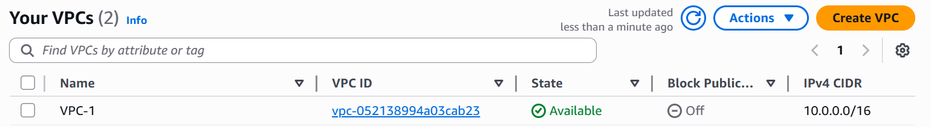

**2.Create Public and Private Subnet**

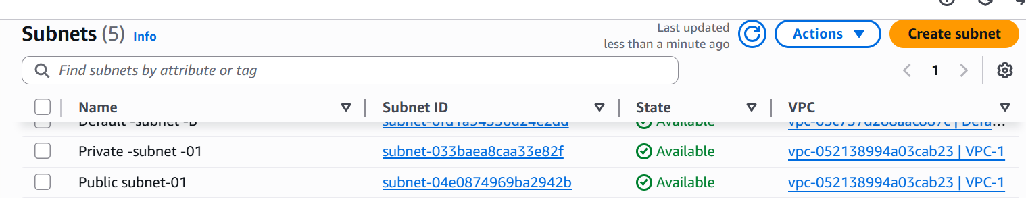

**3.Create and Configure a Route Table**

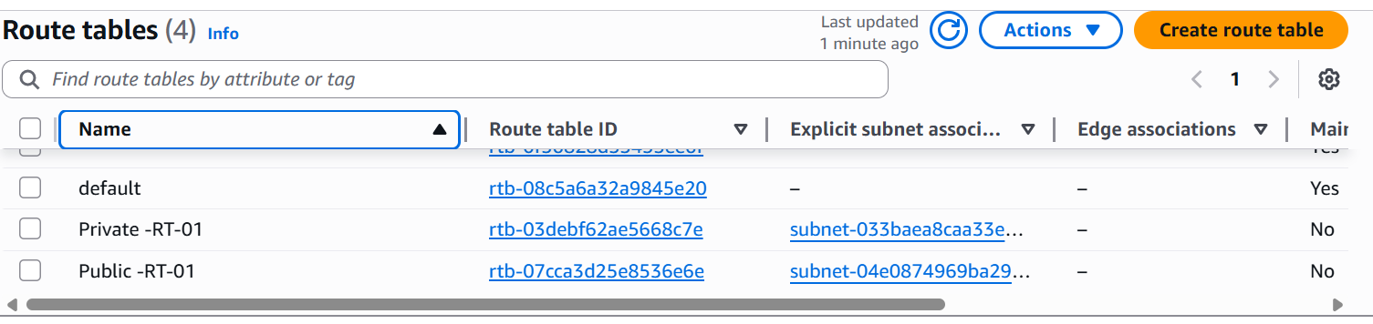

**4.Create and Attach an Internet Gateway(IGW)**

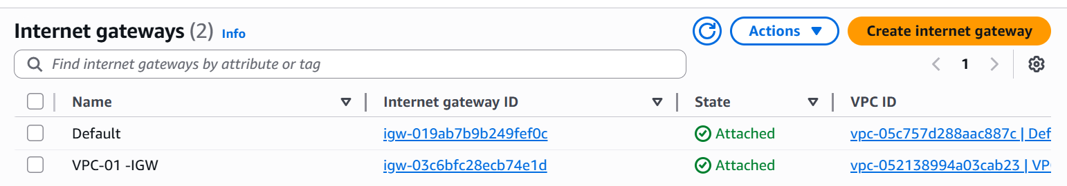

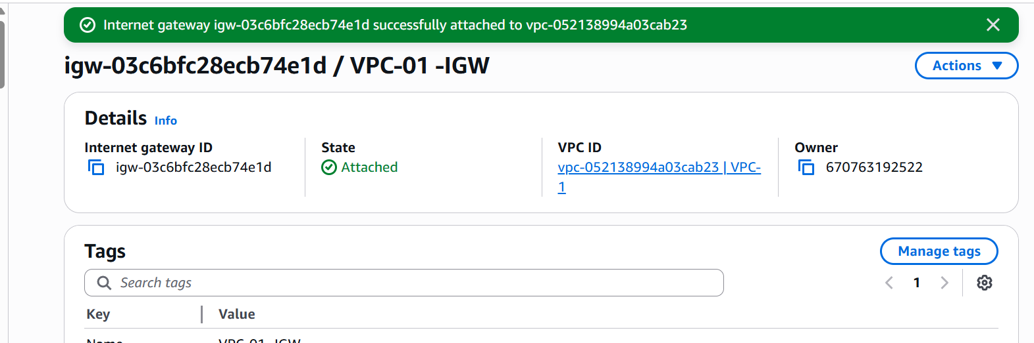

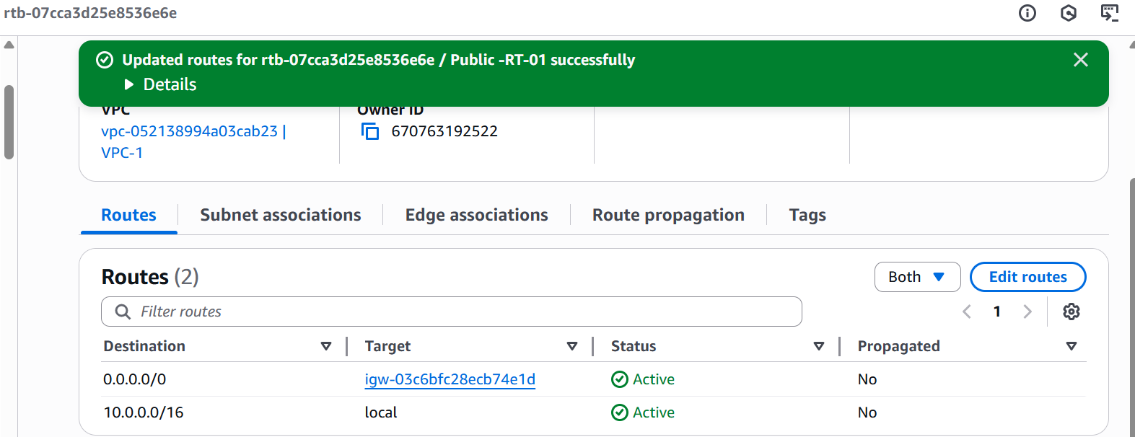

**Launch Ubuntu EC2 Instance in Public Subnet**

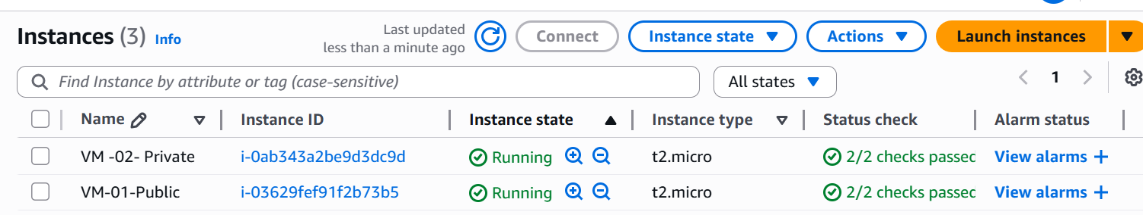

**Testing EC2 Internet Access**  
